NAAN MUDHALVAN ASSIGNMENT DOCUMENT

**COURSE TITLE** : DIGITAL MARKETING

**COLLEGE CODE** 1105

**COLLEGE NAME** : GOJAN SCHOOL OF BUSINESS AND TECHNOLOGY

**NM ID** : 372BB2E51C6FD32BBB042D1CEEB322BF

**NAME** : SABITHA M

**REGISTER NUMBER** 110520106016

**YEAR** : 4TH YEAR

**DEPARTMENT** : ELECTRONICS AND COMMUNICATION ENGINEERING

1. Create a blog or website using Blogspot and Wordpress. Customize the theme design and post new article with 500 words.

Link <https://natureslaststand23.blogspot.com/2023/10/natures-last-stand.html>

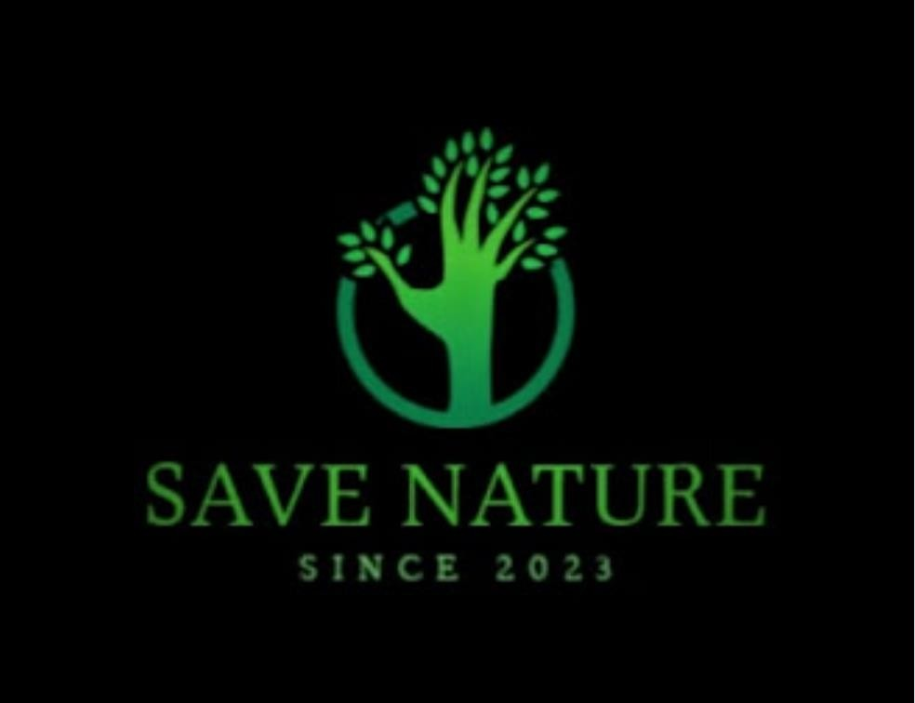

1. Create a New Facebook Business Page and post one social media poster for your brand.

Link: [https://www.facebook.com/people/Save-](https://www.facebook.com/people/Save-Natura/pfbid021pRGroeXYzpTH6UVo9L6aDbxQEe63Pm93GPn59z1GVvtvuR7sJ8kQQrEAktnqAwql/) [Natura/pfbid021pRGroeXYzpTH6UVo9L6aDbxQEe63Pm93GPn59z1GVvtvuR7sJ8kQQrEA](https://www.facebook.com/people/Save-Natura/pfbid021pRGroeXYzpTH6UVo9L6aDbxQEe63Pm93GPn59z1GVvtvuR7sJ8kQQrEAktnqAwql/) [ktnqAwql/](https://www.facebook.com/people/Save-Natura/pfbid021pRGroeXYzpTH6UVo9L6aDbxQEe63Pm93GPn59z1GVvtvuR7sJ8kQQrEAktnqAwql/)

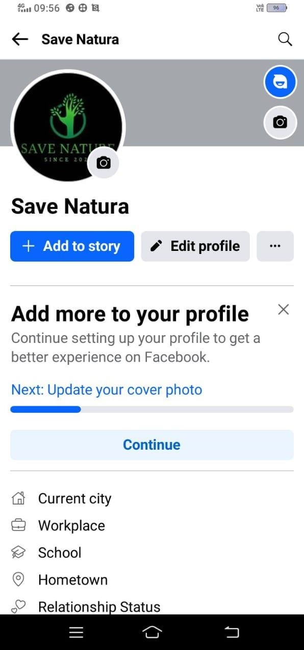

1. Create and design a social media advertisement poster using canva.

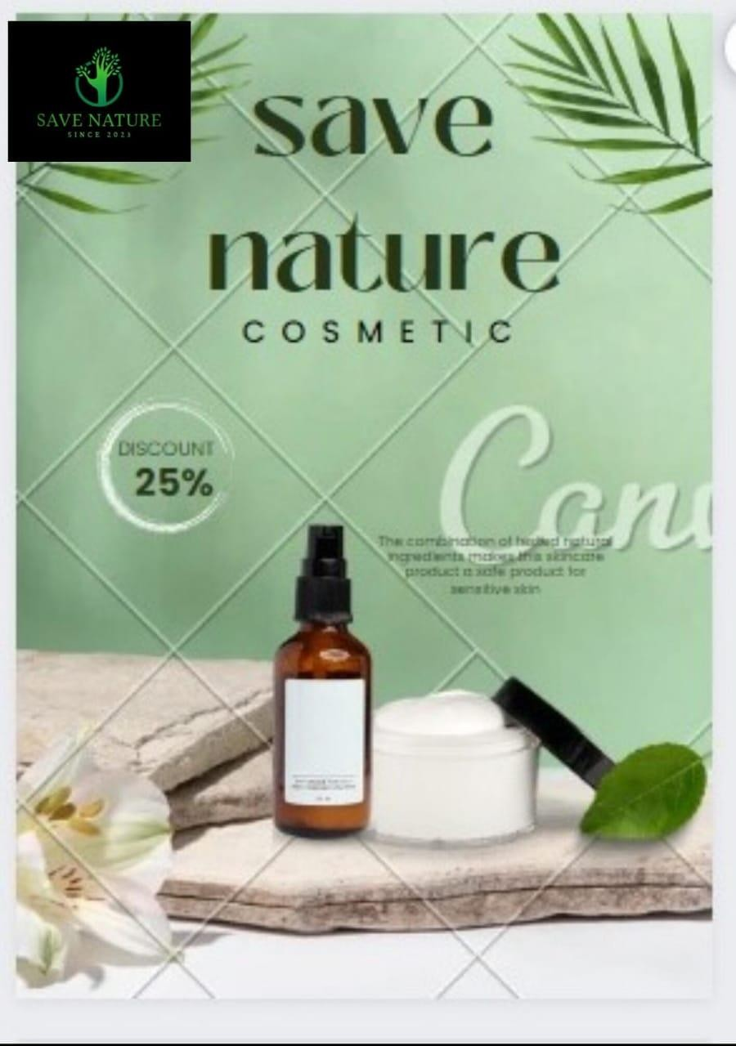

1. Create email newsletter design using MailChimp or canva tool.

Link: [https://www.canva.com/design/DAFx5-](https://www.canva.com/design/DAFx5-qutMk/IddGnW7tYnudHKAwcYjllw/view?utm_content=DAFx5-qutMk&utm_campaign=designshare&utm_medium=link&utm_source=editor) [qutMk/IddGnW7tYnudHKAwcYjllw/view?utm_content=DAFx5-](https://www.canva.com/design/DAFx5-qutMk/IddGnW7tYnudHKAwcYjllw/view?utm_content=DAFx5-qutMk&utm_campaign=designshare&utm_medium=link&utm_source=editor) [qutMk&utm_campaign=designshare&utm_medium=link&utm_source=editor](https://www.canva.com/design/DAFx5-qutMk/IddGnW7tYnudHKAwcYjllw/view?utm_content=DAFx5-qutMk&utm_campaign=designshare&utm_medium=link&utm_source=editor)

